Login at https://secure.ogone.com/Ncol/Prod/BackOffice with your Ogone Backoffice credentials.
You’ll need your PSPID and password for this.
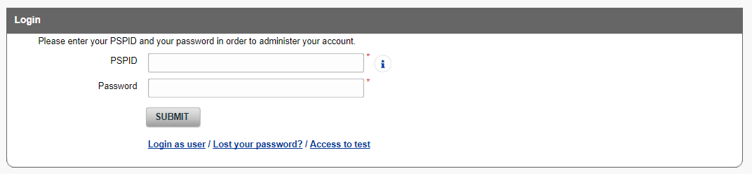
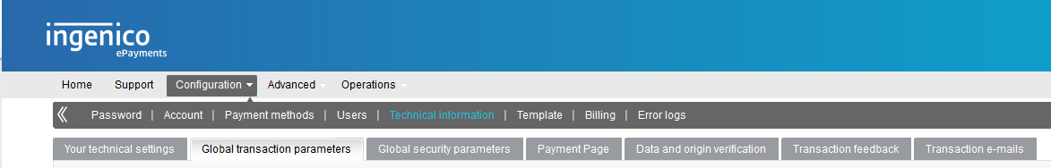
Once logged in click -> -> from the menu.
Check (and modify) the settings in your back office so they look the same as the settings below.
Do this for the following tabs.
